**Lab 1**

**Q1)**

1. **Download Python:**
   * **Visit the official Python website:** [**Python Downloads for Windows**](https://www.python.org/downloads/windows/)**.**
   * **Download the latest Python installer for Windows.**
   * **Choose the version that matches your system (32-bit or 64-bit).**
2. **Run the Installer:**
   * **Double-click the downloaded installer file (e.g., python-3.x.x.exe) to run it.**
   * **Check the box that says "Add Python X.X to PATH". This step is crucial for using Python from the command line.**
3. **Install Python:**
   * **Click "Install Now" to start the installation process.**
   * **Python will be installed on your system.**
4. **Verify the Installation:**
   * **Open the Command Prompt (search for "cmd" in the Windows Start menu).**
   * **Type the command: python --version.**
   * **The installed Python version should be displayed, confirming a successful installation.**

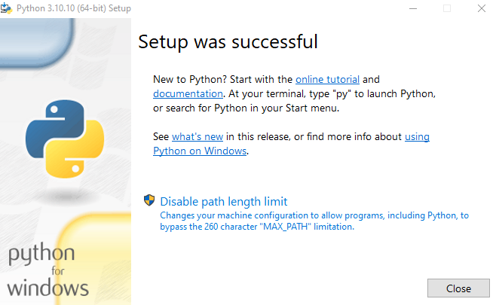

**Q2)**

